By: Dominique Wiest
2/2025

TABLE OF CONTENTS

1. Bona Fide Discount Points. 3
2. QM vs. Non-QM Loans. 3
3. QM -Ability to Repay. 4
4. Non-QM - Ability to Repay. 5
5. Full Doc Loan. 6
6. Mortgage Insurance. 7
7. Prepayment Penalties. 8
8. HPML Loans without Appraisal 8
9. Prior Liens paid with Subject loan. 9
10. Texas Loans. 10
11. Delaware Subprime Loan. 11
12. Same Lender vs. Original Lender. 11
13. Streamline Loan. 12
14. Construction Loan Purpose. 13
15. Disclosure Dates. 13
16. Personal Property Loans 14
17. Counseling Certificate Rcvd Dates and Agency Type. 14
18. Fees. 15

Bona Fide Discount Points.

Loan Additional>>Compliance Information
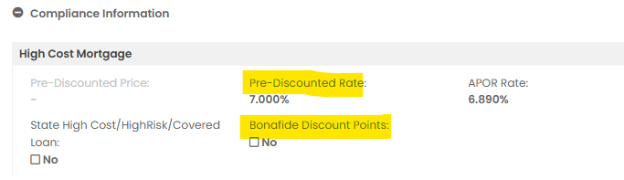

QM vs. Non-QM Loans.

Loan Additional>>Compliance Information

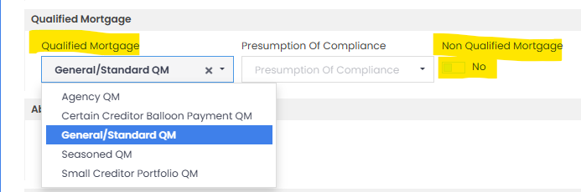

QM -Ability to Repay.

Loan Additional>>Compliance Information

Qualified Mortgage or Exempt
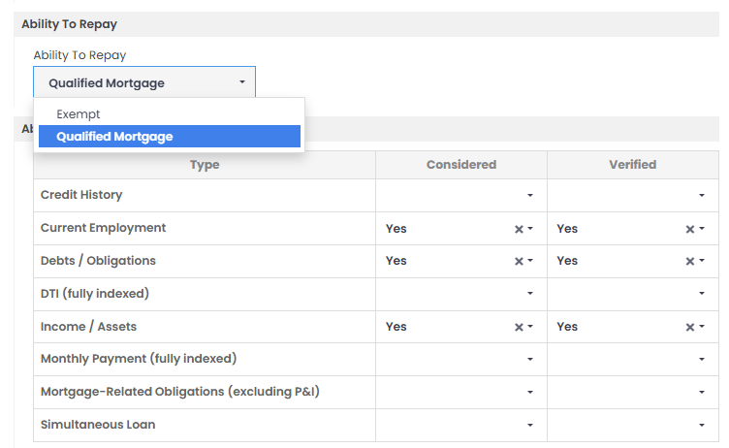

Non-QM - Ability to Repay.

Loan Additional>>Compliance Information

General or Exempt
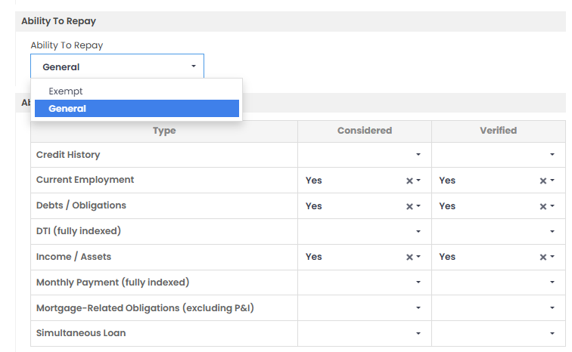

Full Doc Loan.

Loan Additional>>Underwriting

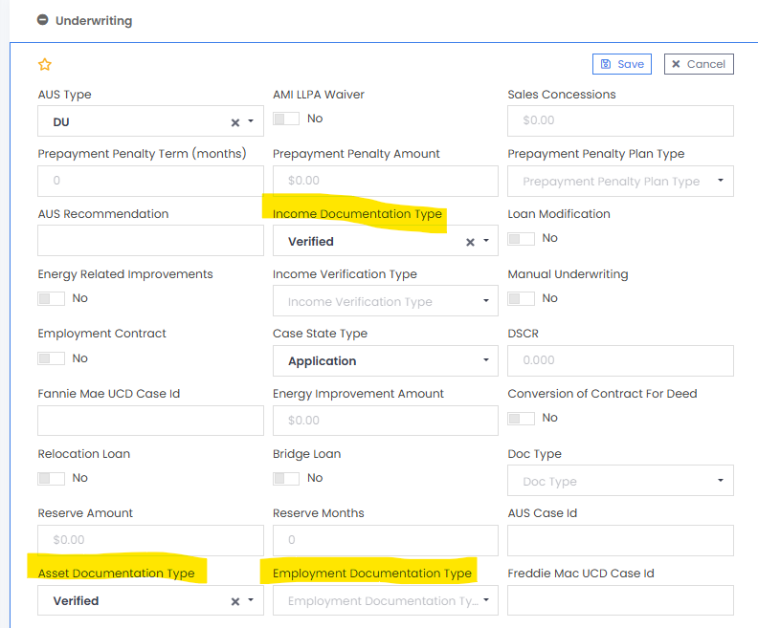

Mortgage Insurance.

Loan Additional>>Mortgage Insurance

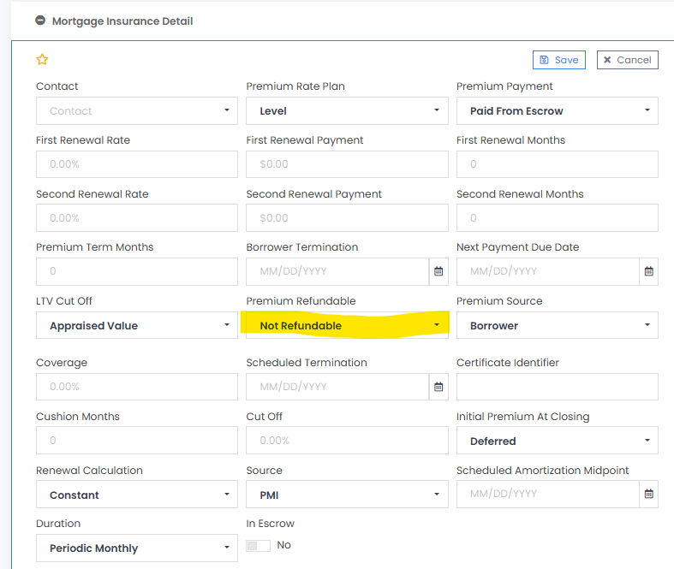

7. Prepayment Penalties.

Loan Additional>>Underwriting

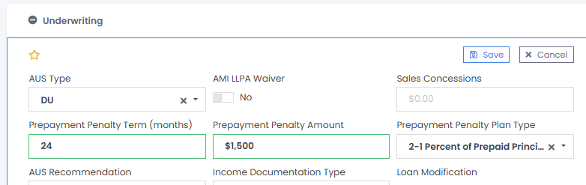

8. HPML Loans without Appraisal

Loan Additional>>Compliance Information>> HPML = Yes>>

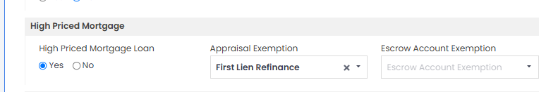

9. Prior Liens paid with Subject loan.
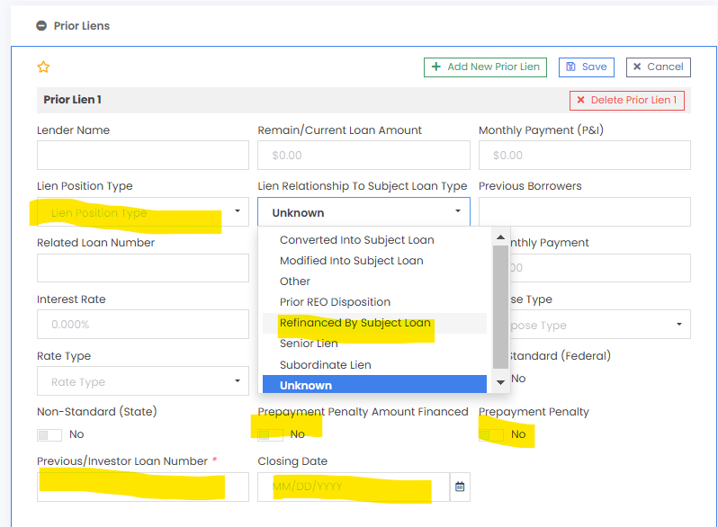
Loan Additional>>Prior Lien

10. Texas Loans.

Loan Additional>>Underwriting

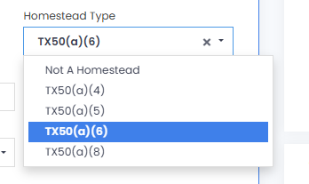

Loan Additional >>Prior Loan

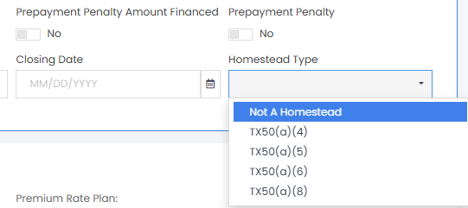

11. Delaware Subprime Loan.

Loan Additional>>Compliance Information

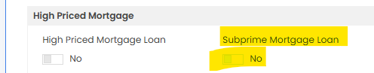

12. Same Lender vs. Original Lender.

Loan Additional>>Underwriting (soon to be Prior Lien)

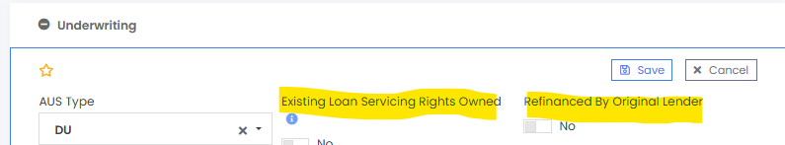

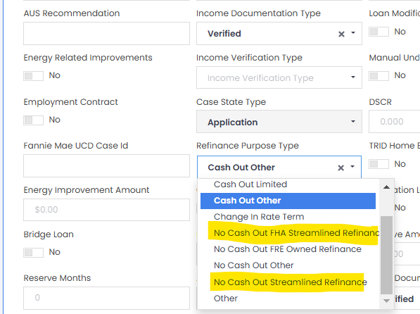
13. Streamline Loan.

Loan Additional>>Underwriting

Or

Loan Additional>>Government Data = VA IRRRL

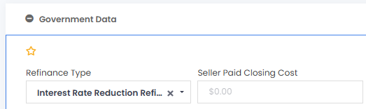

14. Construction Loan Purpose.

Loan Additional>>Construction

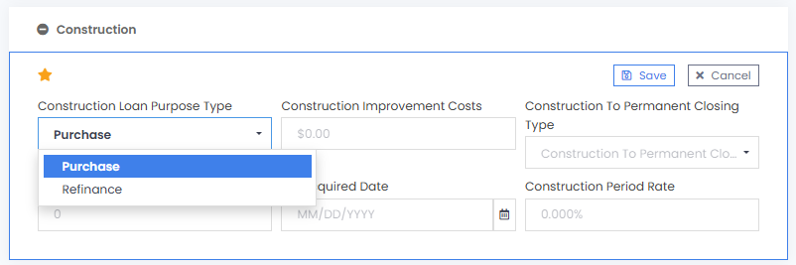

15. Disclosure Dates.

Overview>>Dates>>Processing Dates - by State

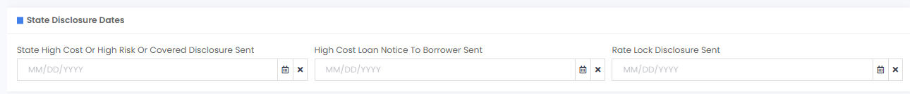

16. Personal Property Loans

Loan Additional>>Manufactured Home

When a Manufactured Home (with HUD seal) has not been declared real property, it is considered personal property. CIO uses the “not attached” toggle to indicate that the property is still personal property.
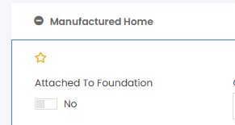

17. Counseling Certificate Rcvd Dates and Agency Type.

Loan Application>>Counselings

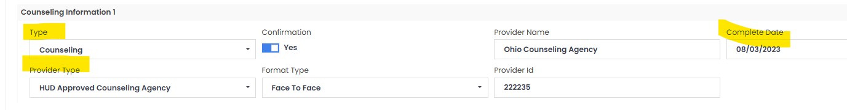

18. Fees.

CIO uses Fee Types, not Fee Name, to determine how a fee is treated.

Steps
- Click on Add Fee and Escrow Type

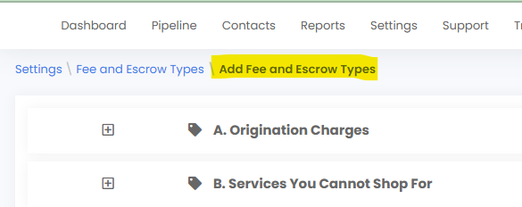

- Choose the Fee and Click on “+” Add the fee

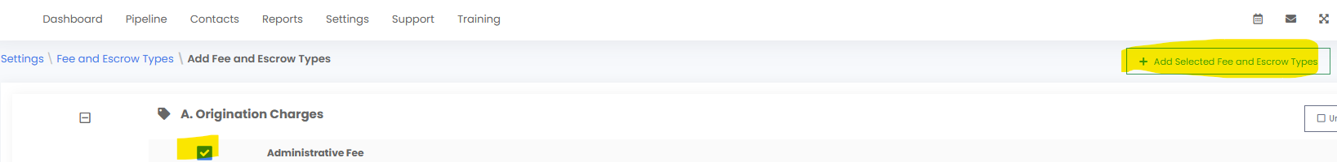

- Return to “Fee and Escrow Types” and find your fee. Click on the pencil next to the fee name.

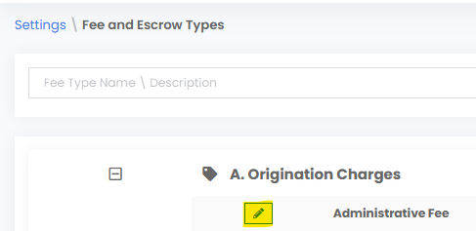

- Notice there is a “Name” and a “Type”. CIO handles the fee based on “Type.” This step is very important because CIO runs all its fee tests based on Fee Type. The “Other Type” will automatically be included in all the fee tests because CIO assumes it is a fee that is included.
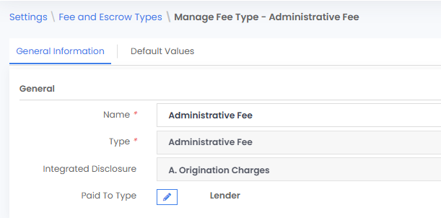

DEMO A Loan (Borrower Demo Loan [12-15-101]
(SC Refi w/ Balloon and PPP, Prior LoanPPP, same lender,
-Identify QM, Prior Loan, PPP, MI, Disclosure Dates)

